

Realtek Start Guide P2P User Interface

Date: 2011/09/01
Version: 0.5

Start Guide P2P User Interface
Files:
All the necessary files are available in the “WiFi_Direct_User_Interface” folder of Realtek software package.

Definitions:

- P2P Device: WFA P2P certified device that is capable of acting as both a P2P Group Owner and a P2P Client.
- P2P Group Owner (GO): An “AP(Access Point)-like” entity that may provide and use connectivity between P2P Clients
- P2P Client: A P2P Device that is connected to a P2P Group Owner.

- Modify wpa_supplicant, wpa.conf, hostapd, hostapd.conf path at first.
In p2p_ui_test_linux.c, default paths for wpa_path, wpa_conf, ap_path and ap_conf were located in our test PC, so it’s mandatory to change these four paths.

- P2P_UI
  - #gcc -o P2P_UI ./p2p_ui_test_linux.c ./p2p_api_test_linux.c -lpthread
  - Launch the P2P_UI with interface (eg. wlan0)
#./P2P_UI wlan0
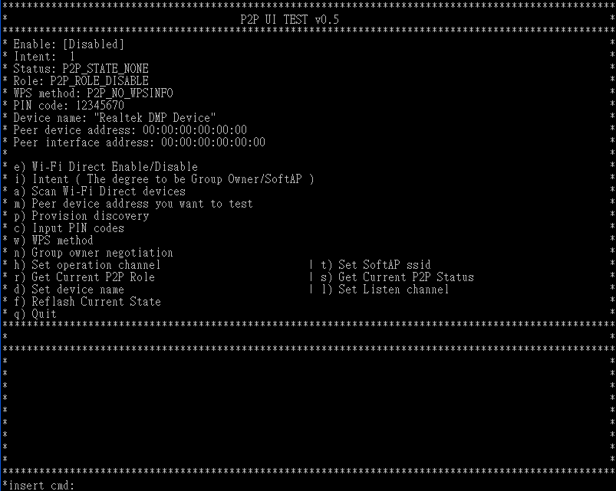
(The window size of user interface is recommended to set 100x40)
- Start using the P2P_UI to connect to other P2P device. (active connection)
We could use P2P functionalities sequentially from top to down as the P2P_UI lists.
  - Enable P2P functionality (insert cmd:e).
[0] Disable P2P device, disable P2P functionalities
[1] Enable P2P device
[2] Enable P2P device and set as P2P client as default
[3] Enable P2P device and set as P2P GO as default
When using user interface in first time, it’s recommended that enable in p2p device mode.
If we select [1], user interface will scan p2p devices automatically.

  - Set P2P device intent
    - It’s the degree that we want our P2P device becoming a P2P client or P2P GO (insert cmd:i).
    - degree from [0-15]
    - ps: intent = 15 means this P2P device must be the P2P GO.
  - Scan P2P devices (insert cmd: a).
After scaning, the P2P_UI will show the scan results of p2p device name, BSSID, if is GO (with *) and config methods that are supported.
Abbreviation for config methods:
LAB: Label VDIS: Virtual Display PDIS: Physical Display
DIS: Display ENFC: External NFC Token
INFC: Integrated NFC Token NFC: NFC Interface
VPBC: Virtual Push Button PPBC: Physical Push Button
PBC: Push Button
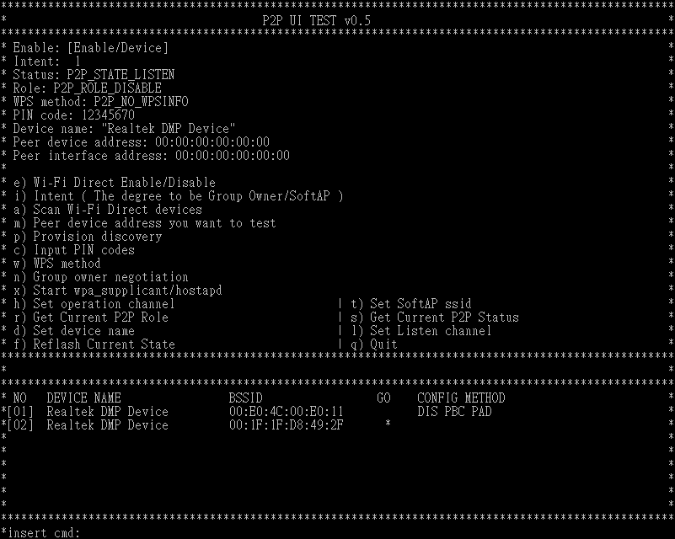
  - Set peer device address (insert cmd: m).
    - From scan list, we could choose one P2P device to start the P2P connection.
    - Input the number of device that we want to do P2P handshake.
  - Issue provision discovery frame (insert cmd: p).
    - The purpose for issuing the provision discovery frame is to set/get the WPS PIN CODE or WPS PBC to/from peer P2P device.
    - In version 0.5, the following procedures of P2P handshake (including set WPS method, group owner negotiation, start wpa_supplicant or hostapd and DHCP client/server) is combined in this step.
    - Select the way to get the WPS configuration method we want to use.
[0]: We input the PIN code that displays on peer device screen.
[1]: Our screen display PIN code and input this PIN code on the peer device
*If we use this WPS configure method, we should input PIN code at first (see 6.4) or use default PIN code: 12345670.
[2]: Both P2P devices will use the WPS PBC
[3]: We input the PIN code that printed on peer device WPS label (like sticker).
    - After 3.5.3, we issue provision discovery and also declaring which WPS method we want to use( this information is inside provision discovery frame)
    - We check p2p status, if status == P2P_STATE_RX_PROVISION_DIS_RSP then we set the corresponding config method to driver.
    - Then we start negotiation.
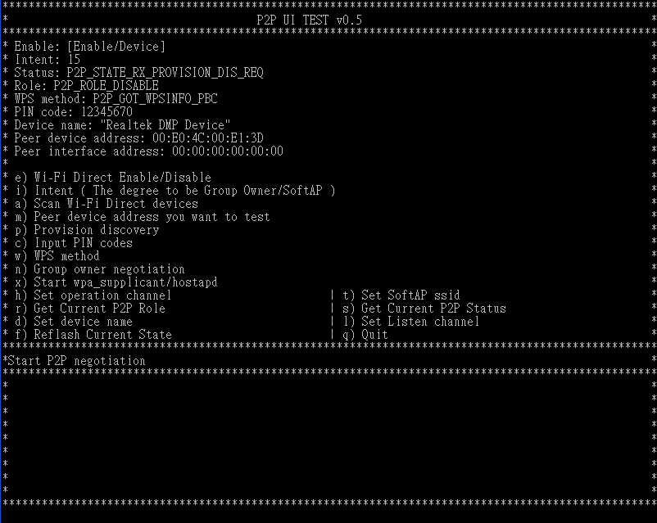
    - In group owner negotiation procedure, we will query status regularly. If we detected that status == P2P_STATE_GONEGO_OK, then we will show the P2P handshake successful message.
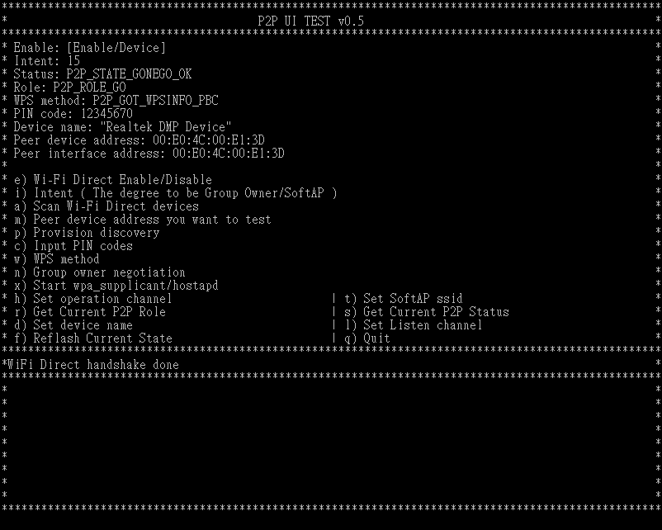
    - Now, in this example, we set intent==1 and our role is client, so we start wpa_supplicant automatically. We also require wpa_supplicant start WPS connection with the config method that we set before.
    - If wpa_supplicant using WPS connection success, it will show wpa state like the following:
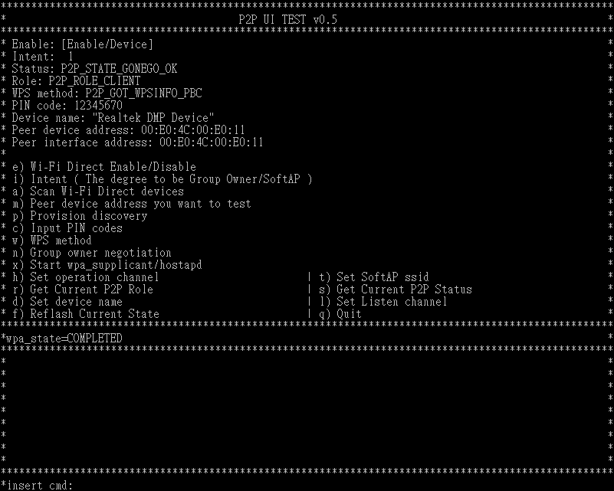
    - After WPS connection successful, user interface will run DHCP client automatically. That time, two P2P devices connected successfully, we could try to ping each other.
    - Otherwise, if our role is P2P GO, then we start hosapd automatically and require it starts WPS connection with the config method that we set before. The following is the information that the client connected successfully, using WPS connection.
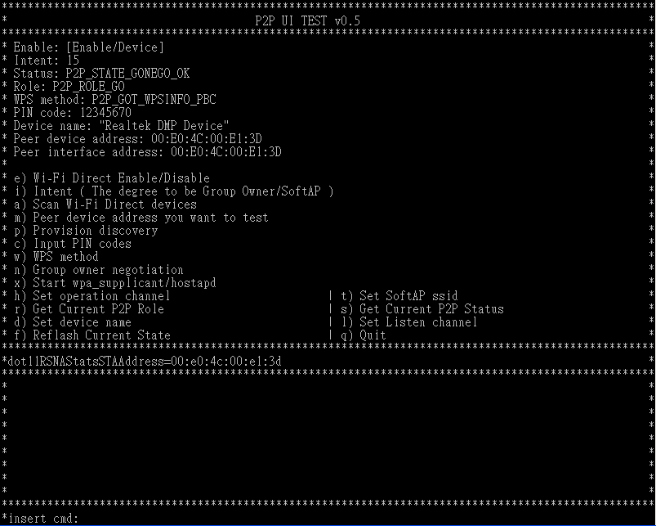
    - If WPS connection success, GO will run DHCP server. That time, two P2P devices connected successfully, we could try to ping each other.
*Our P2P_UI is implementing in Fedora, so the route with DHCP server in P2P_UI is writing as default route in Fedora. If you are using another Linux OS, it’s recommended that changing DHCP server route in P2P_UI or marked #define DHCP.

- Start using the P2P_UI to be connected by other P2P device. (passive connection)
  - We enable p2p functionalities at first (enable as P2P device)
  - If we enable as P2P device, then we do polling status with interval POLLING_INTERVAL.
  - Set P2P device intent as 3.2
  - Set scan as 3.3, for our driver, we only accept P2P handshake request that in our scan list.
  - If we detected that peer P2P device issue provision discovery request, our status will be P2P_STATE_RX_PROVISION_DIS_REQ, then our driver will respond provision discovery response frame and we will check what config method that peer P2P device want to set as WPS connection and do the corresponding actions:
    - If it’s PIN code and peer device want us to input PIN code on their display, then we will show the following information and we need to input peer’s PIN code,

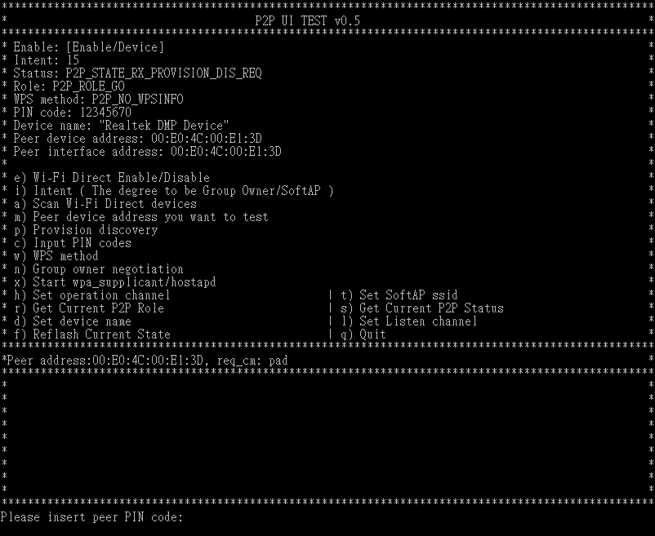
    - If it’s PIN code and peer P2P device wants to input our PIN code on their device (or input the PIN code that displays on our label), then we need insert command “c” as accepted.
    - If it’s PBC, then we need insert command “b” as accepted.
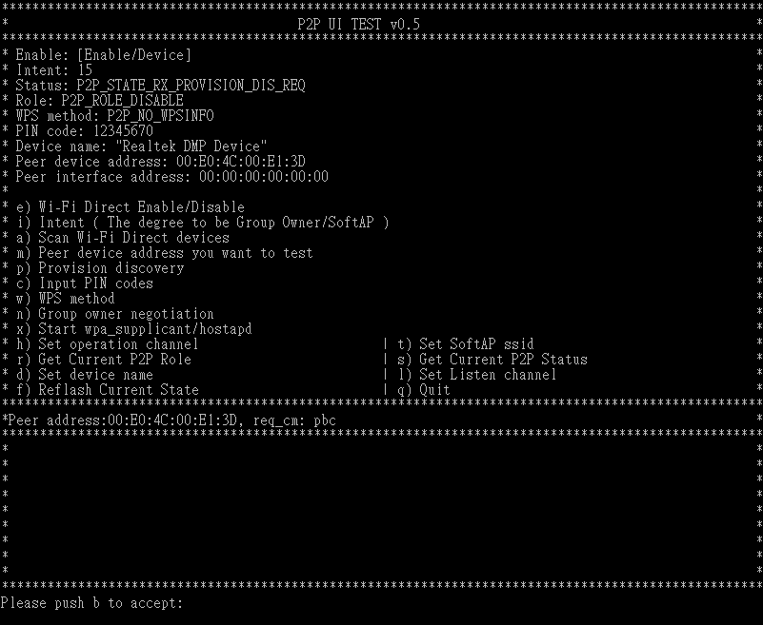
  - The following procedures will be similar as 3.5.6

- When P2P device wants to connect P2P GO.
  - When our driver becomes as P2P GO, we still do polling our driver status to check if some other P2P devices connected.
  - If P2P GO received provision discovery request from others, the state in P2P GO will be P2P_STATE_RX_PROVISION_DIS_REQ and will respond provision discovery response.
  - UI will show the information like 4.5.1~4.5.3.
  - When one P2P device connects to P2P GO, it doesn’t need to do further negotiation handshake. So driver will use the corresponding configuration method to do WPS connection.
  - If WPS successful, P2P GO successfully connected with other P2P device, it will show like 3.5.11
  - We could test it’s scenario without any P2P handshake before, just Enable P2P device and set as P2P GO as default.
- For customers optimized their own user interface, we keep the previous version of commands that letting customers to start P2P handshake procedure individually.
  - Marked #define P2P_AUTO 1 before compiled P2P_UI.
  - With this version, the first 3 steps are the same as 3.1~3.4
  - Issue provision discovery frame (insert cmd: p).
    - The purpose for issuing the provision discovery frame is to set/get the WPS PIN CODE or WPS PBC to/from peer P2P device.
    - Select the way to get the WPS configuration method we want to use.
[0]: We input the PIN code that displays on peer device screen.
[1]: Our screen display PIN code and input this PIN code on the peer device
*If we use this WPS configure method, we should input PIN code at first (see 6.4) or use default PIN code: 12345670.
[2]: Both P2P devices will use the WPS PBC
[3]: We input the PIN code that printed on peer device WPS label (like sticker).
    - After 6.3.2, we issue provision discovery request and also declaring which WPS method we want to use( this information is inside provision discovery frame)
  - Input PIN codes (insert cmd: c).
    - This step is optional because the P2P_UI already provides the default PIN Code
    - The P2P_UI will check the validation of the inputted PIN code. If we want use [1] in 6.3.2, it’s recommended that we input PIN code before issuing provision discovery
    - If we select [0] in 6.3.2, we input PIN code that displays on the screen of peer P2P device.
    - We don’t need to input PIN code if you select the [2] in 6.3.2
    - If we select [3] in 6.3.2, we should input the PIN code which printed on the label of peer P2P device.
  - Set WPS configuration method (insert cmd: w).
    - This command is used to inform the P2P driver that the P2P_UI already received the WPS PIN code or WPS PBC. The WPS PIN code and WPS PBC should be acquired by using the command 6.3 and 6.4.
    - We will set WPS configuration method based on 6.3 we issued.
If you select the [0] in 6.3, we will choose the [1] here.
If you select the [1] in 6.3, we will choose the [2] here.
If you select the [2] in 6.3, we will choose the [3] here.
If you select the [3] in 6.3, we will choose the [1] here.
  - Issue group owner negotiation ( insert cmd: n)
    - It will do the group owner negotiation handshake. If our intent is lower than peer device, the P2P_UI would start wpa_supplicant automatically and act as P2P client.
    - Else, if our intent is higher than peer device, the P2P_UI would start hostapd automatically and act as P2P GO.
    - For group owner negotiation procedure, it could be issued by one of two P2P devices.
  - DHCP
    - If wpa_supplicant reported “wpa_state=COMPLETED”, it means P2P connection is established successfully and P2P_UI will start dhclient automatically to try to get the IP from the P2P GO.
    - If hostapd reported “dot11RSNAStatsSTAAddress=XX:XX:XX:XX:XX:XX”, it means the P2P connection is established successfully and the P2P_UI will start DHCP server automatically.
  - For the other P2P device (passive connected), it could do re-flash current state to check whether P2P device connected using P2P handshake.
- Optional commands.
The following are some optional commands that could set or get information from drivers.
  - Set operation channel (insert cmd: h)
    - It is optional command because the P2P_UI will have the rule to determine the default value for the operation channel. However, this information will be ignored if this P2P device is the P2P client after the group owner negotiation handshake. Also, if hostapd is running, we could not change this value, same as 7.2 and 7.5
    - The P2P_UI will use the value of “channel“ in /hostapd.conf as default value.
    - This operation channel is the channel number which the P2P GO should stay if the local P2P device is the GO.
    - Notice that the value should be the same as the value of “channel” in /hostapd.conf
  - Set softAP ssid (insert cmd: t)
    - It’s optional because the P2P_UI will use the content of “ssid” in /hostapd.conf as default
    - This command will inform other drivers the ssid string if this P2P device is the GO.
    - Notice that the value should be the same as the content of “ssid” in /hostapd.conf
  - Get current P2P role (insert cmd: r)
You can check the P2P role which the driver is acting as.
0: Disable
1: P2P Device
2: P2P Client
3: P2P GO
  - Get current P2P status (insert cmd: s)
You can check the current P2P status that the driver stands for.
0: P2P_STATE_NONE
1: P2P_STATE_IDLE
2: P2P_STATE_LISTEN
3: P2P_STATE_SCAN
4: P2P_STATE_FIND_PHASE_LISTEN
5: P2P_STATE_FIND_PHASE_SEARCH
6: P2P_STATE_TX_PROVISION_DIS_REQ
7: P2P_STATE_RX_PROVISION_DIS_RSP
8: P2P_STATE_RX_PROVISION_DIS_REQ
9: P2P_STATE_GONEGO_ING
10: P2P_STATE_GONEGO_OK
11: P2P_STATE_GONEGO_FAIL
12: P2P_STATE_RECV_INVITE_REQ
13: P2P_STATE_PROVISIONING_ING
14: P2P_STATE_PROVISIONING_DONE
  - Set device name (insert cmd: d)
Set the device name which will be seeing by the other P2P devices. In Default we get this name from /hostapd.conf.
    - It’s optional because the P2P_UI will use the content of “ssid” in /hostapd.conf as default
    - This command will set the P2P device name which will be seeing by other P2P devices.
    - Notice that the value should be the same as the content of “ssid” in /hostapd.conf
  - Set listen channel (insert cmd: l)
Set the listen channel where the device will stay in the listen state, the listen channel will set channel 1, 6, 11 only, as the spec. described.
  - Reflash current state (insert cmd: f)
It will reflash current state and other information that P2P_UI maintains.
  - Quit (insert cmd: q)
Quit P2P user interface, P2P functionality will be disabled.

